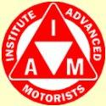

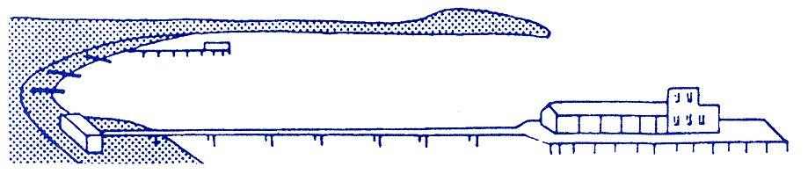
BOURNEMOUTH & DISTRICT GROUP
News @ 1096 September 2016
The speaker at our social meeting on 1st September will be Martyn Underhill, the Dorset Police and Crime Commissioner. We hope as many of you as possible will be able to come along and please do bring family and friends.
Our venue is, as usual, Kinson Community Centre, Pelhams Park, Millhams Road, Kinson starting at 7.30p.m.
Attached/enclosed with this newsletter are your invitation, notice and nomination form for our forthcoming AGM to be held at our usual venue at Pelhams on 6th October starting at 7.30p.m. We would very much welcome members who wish to become further involved with the group and if you feel you would like to become a member of the committee then please complete your nomination form and have it proposed and seconded by two other full IAM members.
We wish to congratulate Michael Wilson and Emma Keegan who have recently passed their test.
IAM RoadSmart has more than 60 years’ unrivalled knowledge and experience of riding and driving. Our regular tips provide helpful hints for all road users.
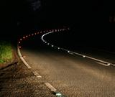

Low sun, no fun
As autumn brings shortening daylight hours, Simon Elstow advises drivers on dealing with low sun and dazzle, especially during the morning and afternoon commute.
- Always keep a good pair of sunglasses in the car – they really will make a big difference.
- If you can’t see, do the obvious thing and slow down, keeping an eye on the vehicle behind in case the following traffic can’t see you against the sun.
- If the sun is behind you, it’s in the eyes of drivers coming towards you – be aware that they might not see you or the road markings between you and them.
- Low sun behind can dazzle you via your mirrors, so be ready to dip the mirror and remember to check over your shoulder for vehicles in your blind spot.
- Low sun highlights windscreen scratches and grime which can hinder your view, so keep your washer bottles topped up with a good quality screen wash and change your wipers every year.
- Turn on your headlights before sunset and keep them on for an hour after sunrise so that it’s easier for other drivers to see you in twilight.
Simon Elstow said: “Dirty windscreens make it even more difficult for drivers to see in the low sun we get every morning and late afternoon as winter draws closer. Your heater is often on the de-mist setting, blowing traffic fumes, suspended oil and smoke onto the inside of the screen which quickly builds up a film of grime which is a major cause of glare. Clean your screen inside and out with glass cleaner at least once a week.”

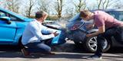

Road rage – don’t be a victim

- If someone is being confrontational or aggressive, don’t make eye contact and don’t react visibly.
- Let the other driver go on ahead. You might feel wronged, but letting the other party go will make no difference to the rest of your day.
- Name and shame! If you or better, your passengers, can film any behaviour on your mobile phone it will help in terms of evidence, including the registration number of the other vehicle involved.
- If the conflict is more serious and other processes aren’t working; call the police, especially if you feel there is a threat or possibility of violence against you.
- Sorry helps. If you were at fault, admit it and apologise. If you feel upset or emotional pull over and get some fresh air or walk around if you need to before resuming your journey.
- Again find some distraction, like listening to the radio - move your mind deliberately onto something else – deliberately driving well would be a good example – but don’t dwell on the incident.
Richard Gladman, head of driving and riding standards said: “Road rage does not affect everyone every day. If you’re finding it is happening very often, you might want to think about how you engage with other road users.”
He concluded: “No-one need experience road rage, but it us up to each of us to ensure it stays that way.”

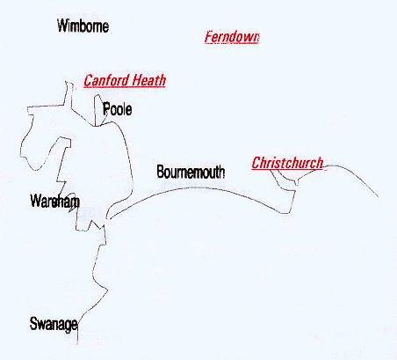

Disclaimer: The views and opinions expressed in News @ 1096 do not necessarily state or reflect the views of the Bournemouth & District Advanced Motorists Group

