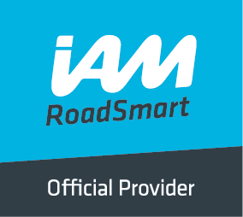
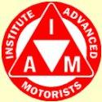
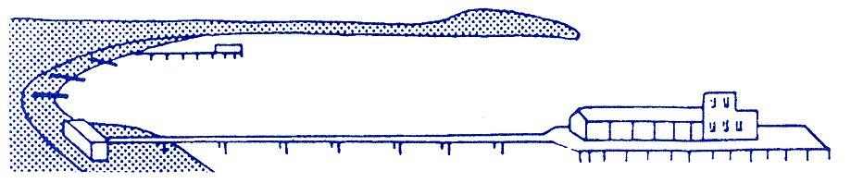
BOURNEMOUTH & DISTRICT GROUP
News @ 1096 November 2017
Thanks to our extremely dedicated Observers, the Bournemouth group has been very successful of late having achieved an almost perfect pass rate with just one recent failure. Our latest scorecard is very impressive as shown below:
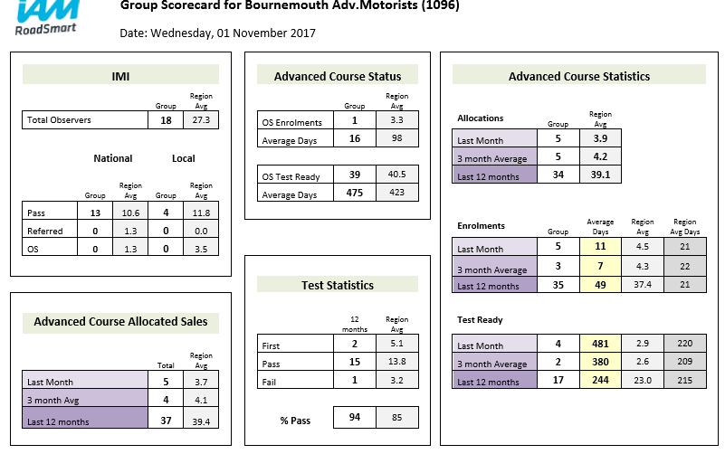
Congratulations to:
Name Pass date Observer Name Pass date Observer
Mr Anthony Brent 28/8/17 Aila Peacock Mrs Jacqui Baker 22/8/17 Mike Staton
Ms Katie Bennett 8/9/17 Keith Bowers Mr Duncan Bryson 15/9/17 Kevin Etheridge
Mr Robin Ayling 20/10/17 Roger Brigham Mr Gary Kilminster 20/10/17 Nick Hanham

Mr Chris Reay from Dorchester Group has recently passed his Masters having been coached by Richard Jolly.

Protyre IAM Visit on 2nd November, 2017
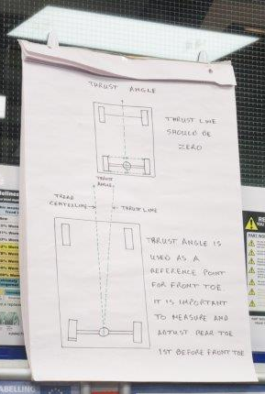
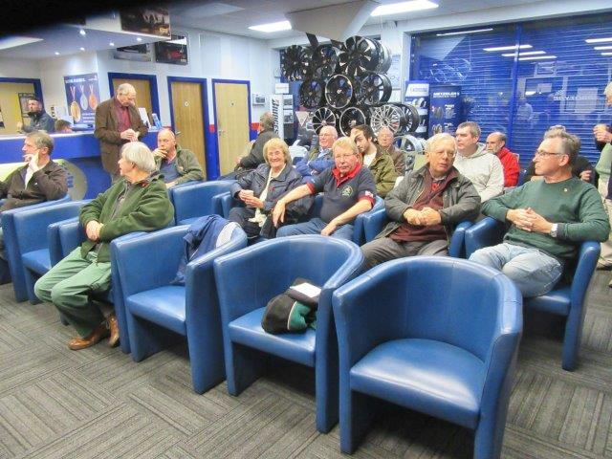
We were met at the door by Mike, former manager, and the night started in an excellent manner with drinks all round; soft drinks of course.

We then went on to a very interesting and in depth talk by Mike about wheel toe in, toe out and wheel alignment and their importance to tyre life and the driveability of the car.
The talk went on to tyre changing and wheel balancing with a strong emphasis on tyre tread depth and why the legal limit of 1.6mm is not the time to change the tyre but 3mm depth is the ideal point for safe operation.
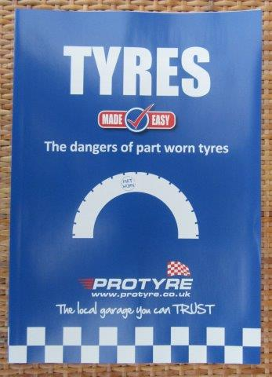
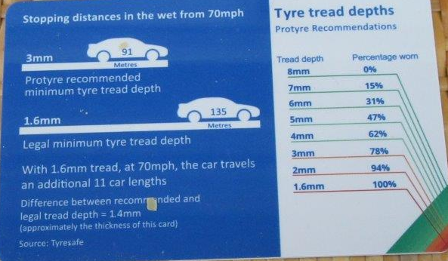
Whilst we were being given a guided tour of the storage area, we were given an insight into the company’s ambition to become the third largest tyre supplier in the UK.
Micheldever Tyre and Auto Services Limited, trading as Protyre and including Tyreland, has been sold to Sumitomo Rubber Industries, one of the largest in the world.
The stores contained some 6,000 tyres from budget brands through to medium and premium quality tyres, we were also told that this depot receives a 17 ton truck load of tyres nightly, that’s a lot of black round things!

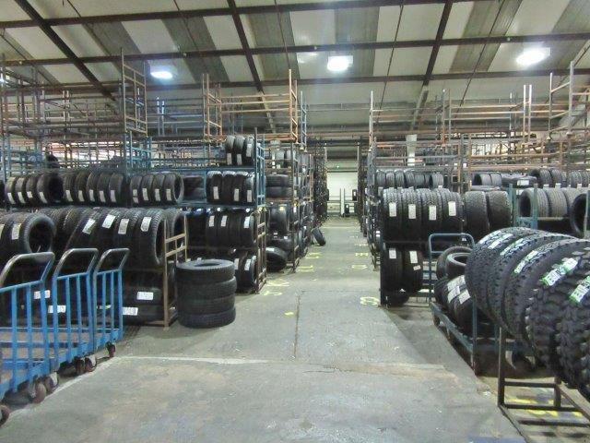

Next we went out to the workshop where wheel alignment was demonstrated on the latest computerised equipment and showed what could and couldn’t be adjusted. It was interesting to see how all four wheels where adjusted to make sure the car didn’t go down the road in a crab like fashion, again to preserve tyre life.
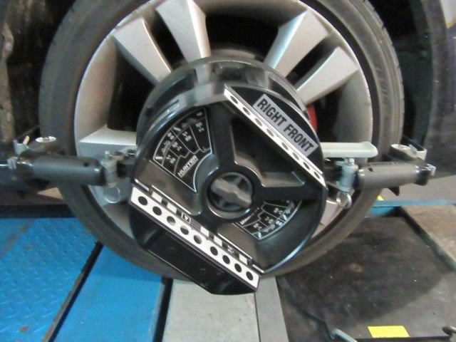
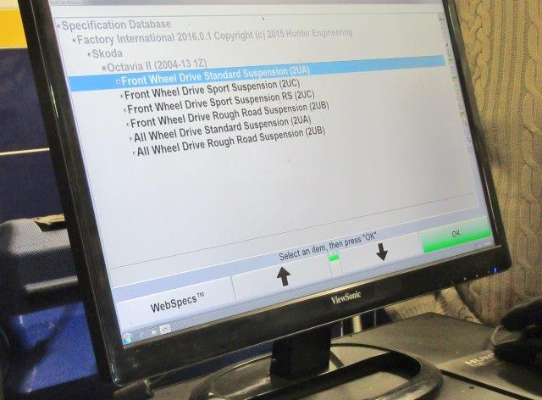
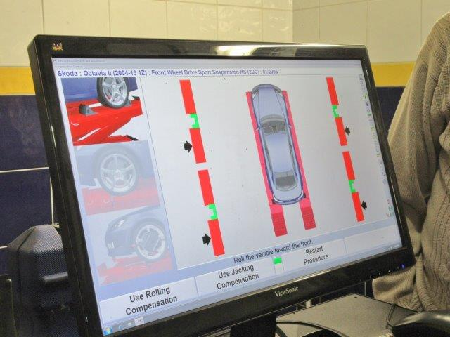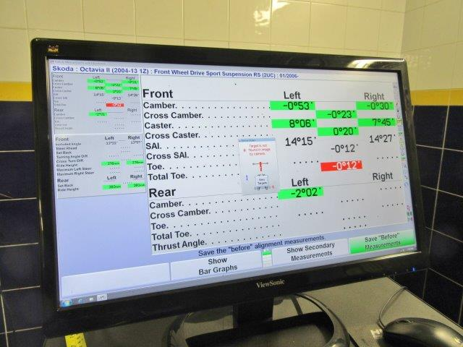
On to the ramp work where it was shown how much care was taken not to damage the wheels or the locking wheel nuts. If a car should come in with a damaged alloy wheel, it was at this point before any new tyre could be fitted, the customer would be informed of the problem and the wheel could be taken to an independent wheel refurbishment company at the rear of Protyre’s premises.
We were given a demonstration of tyre changing and the care taken to ensure the wheel was clean enough to make an effective seal.
After the tyre was fitted, the wheel went onto an automatic inflation and pressure setting machine then over to the wheel balancing machine where it was demonstrated how the wheel could have balance weights placed in different spots and still be balanced correctly. The mating surface of the wheel and hub is checked and cleaned, then the wheel is refitted to the car and care is taken not to over tighten the fixings and that it is torqued up correctly.
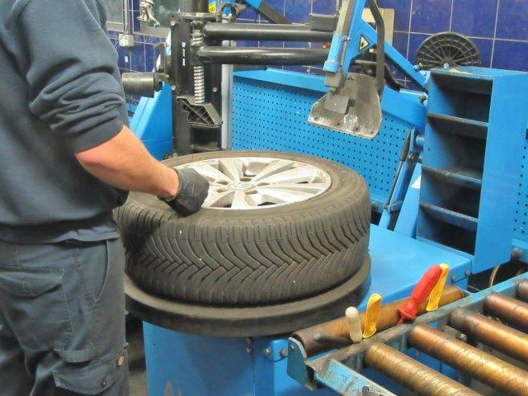
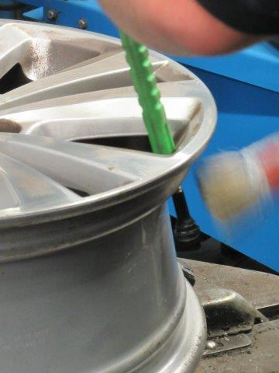

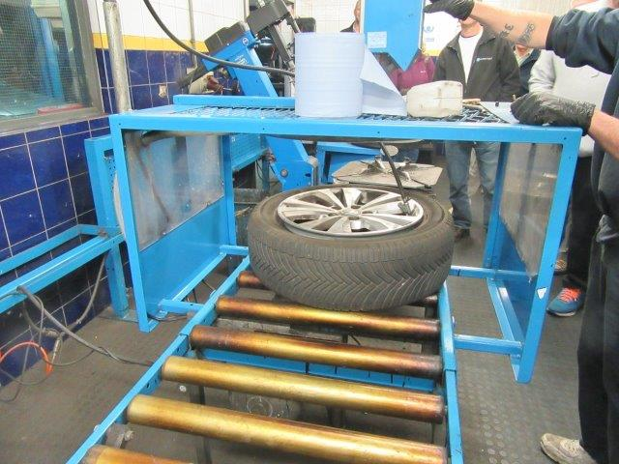
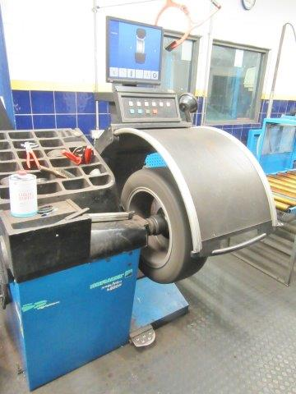
The evening ended with a question and answer session with all the staff on hand being very helpful and answering all our questions willingly.
It was clear the staff is dedicated and always puts the customer first.
As a bonus, we were all given a “goodie” bag containing a tyre depth gauge, ice scraper, baseball cap, pen and sweets!!!
If a visit is needed for any of their services, which Richard and John did two days later and both claimed the 10% discount that was on offer to IAM members, make sure you have your national membership card with you!
The establishment also caters for motorbikes and has a very comprehensive stock of various makes of tyres.
Vehicle checks, including MOT’s are also undertaken.
We would like to thank all staff and area manager for staying late and making our visit so enjoyable.
Nick Hanham Observer and John Williamson

We hope you will all come along to our Christmas get together for a relaxed couple of hours chat and catch up on 7th December at 7.45pm. Nibbles, tea/coffee and soft drinks will be provided. For those new members who haven’t been before, we meet at Kinson Community Centre, Pelhams Park, Millhams Road, Kinson, Bournemouth BH10 7LH. Partners and friends are also invited. Just to remind members, there will not be a meeting in January.
The committee wishes all members a very happy Christmas and best wishes for 2018.
Drive safely!
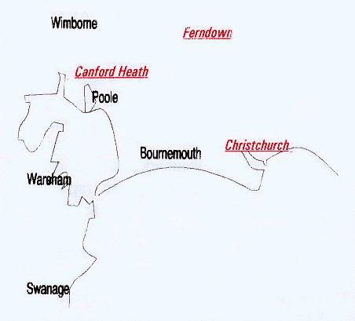

Disclaimer: The views and opinions expressed in News @ 1096 do not necessarily state or reflect the views of the Bournemouth & District Advanced Motorists Group.

