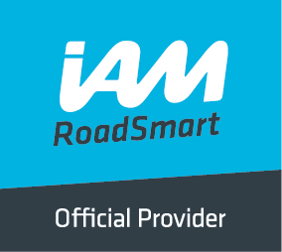
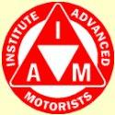
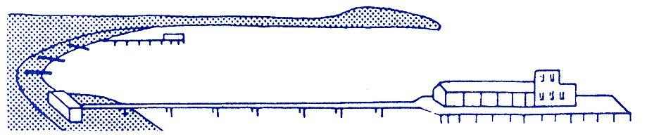
BOURNEMOUTH & DISTRICT GROUP
News @ 1096 July 2017
We were treated to a most interesting and informative talk by John Larty from Kwik Fit at our Thursday meeting and we would like to thank all members and guests who turned up on such a warm evening to make the evening such a success.
Richard Jolly hosted the evening and reported to us that our group has now achieved an IAM RoadSmart pass rate of 96% for candidates taking their test compared to the regional average of 87%. This result is due to the tremendous dedication of our volunteer observers who devote so much of their own time helping associates.

Local authorities to benefit from ‘landmark’ investment strategy
Wednesday 5th July 2017
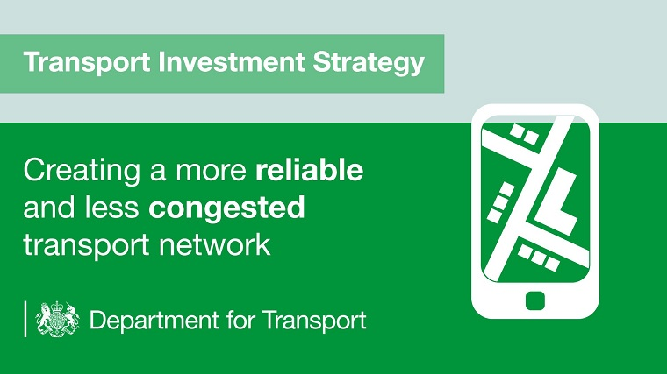
Local roads are set to benefit from a new multi-billion pound improvement fund, unveiled by the DfT today (5 July).
The transport investment strategy sets out a new long-term approach for Government infrastructure spending - including funding for local authorities to improve, or replace, A roads under their management.
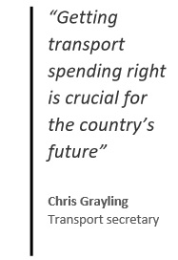
The strategy aims to improve productivity and connectivity of towns and cities as well as tackling bottlenecks and traffic jams. It also seeks to take away the ‘misery’ of lorries and through-traffic ‘thundering’ through rural villages on main roads.
Transport secretary Chris Grayling says the new approach is designed to ‘make transport work for the people who use it’.
- Stakeholder reaction
The transport investment strategy also plans for a new ‘rebalancing’ measure, which will judge how investment programmes contribute to a more balanced economy, and prioritises investment that increases productivity or growth, improves reliability and tackles congestion.
Further plans include the creation of the ‘Major Road Network’ with access to a multi-billion pound road fund, funded by Vehicle Excise Duty (VED), for improvements such as bypasses.
Chris Grayling said: “Getting transport spending right is crucial for the country’s future.
“The transport investment strategy sets out a blueprint for how we can harness the power of transport investment to drive balanced economic growth, unlock new housing projects, and support the government’s modern industrial strategy.
“At the heart of our approach is a plan to make transport work for the people who use it and for the wider economy.”

Stakeholder reaction
The RAC says the announcement is 'good news' for motorists across the UK - adding that many are currently in the dark about where responsibility lies for the building and maintenance of local A-roads
Nicholas Lyes, RAC roads policy spokesman, said: “While motorways and major A-roads are benefitting from dedicated funding and have a future funding plan in place through vehicle excise duty receipts, local authorities have struggled to cope with fixing and upgrading those A-roads which come under their control.
"We hope today’s announcement of a Major Road Network will lead to significant investment with a programme of new local road projects tackling some of the country’s worst congestion hot-spots and pinch-points which will benefit business and private motorists alike and act as a stimulus to economic growth." Courtesy of DfT website

Country Roads Brake before the bend, not on it
59% of all fatalities occur on country roads. These roads often have sharp bends and blind bends which can hide unexpected hazards. Stay in control and give yourself time to react because you never know what’s around the corner. THINK! Brake before the bend, not on it.

The facts
- 59% of all fatalities occur on country roads
- Three people die each day on average on country roads
- The number of people killed on country roads is nearly 10 times higher than on motorways
- In 2015, 10,307 people were killed or seriously injured on country roads in Great Britain

The law
You must not drive faster than the speed limit for the type of road and your type of vehicle. The speed limit is the absolute maximum and it doesn’t mean it's safe to drive at this speed in all conditions.

THINK! Advice
The best drivers read the road ahead and anticipate potential hazards. Look out for upcoming bends, hidden dips, blind summits and concealed entrances.
Country roads often have sharp bends. To stay in control and give yourself time to react to unexpected hazards, brake before the bend, not in it.
Overgrown verges, bushes and trees on country roads can block your view and potentially obscure an oncoming hazard. Always drive at a speed which will allow you to stop in the distance you can see to be clear (double that on a single track road). Allow more time to stop on wet or slippery surfaces.
The speed limit is a limit not a target. The national speed limit on single carriage roads is 60mph, but there will be times you need to drive under that in order to drive correctly for the conditions. In fact most people do on these roads – the average free flow speed is 48mph.
If you get stuck behind a slow moving vehicle, be patient. Dips in roads, bends and other junctions joining your road often hide oncoming vehicles, so unless it's absolutely safe, don't overtake.
If passing more vulnerable road users such as horse riders, cyclists and walkers, pass wide and slow.
Even if you’re familiar with a country road, never take it for granted as the conditions can be different every time. Courtesy of Road Safety GB
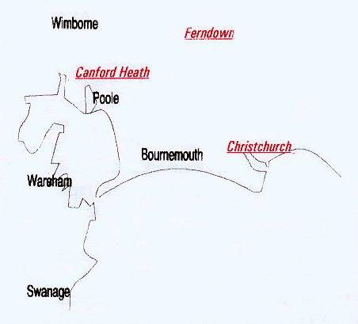
We would like to remind members that there will not be a meeting in August but we look forward to seeing you all at our next meeting on Thursday 7th September when we hope to have a speaker from Bliss Aviation. Our meeting on October 5th is our AGM – your opportunity to vote in new committee members!

