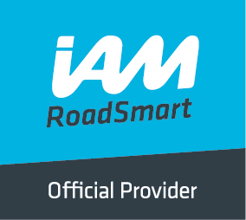
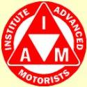
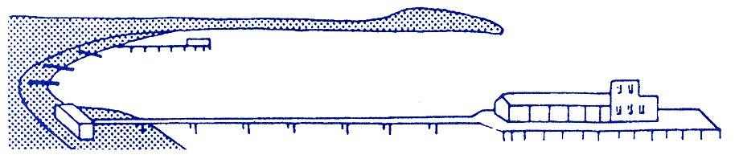
BOURNEMOUTH & DISTRICT GROUP
News @ 1096 January/February 2017
A Happy New Year to you all and many congratulations to our very own local IAM Roadsmart examiner, Chris Smith, who has been awarded the prestigious Queen’s Police medal by Her Majesty The Queen as part of her New Year’s Honours, due to his passion and energy for road safety. One of Chris’ biggest passions is motorcycle safety and Dorset BikeSafe which as lead he co-ordinates and delivers lessons while mentoring other riders.
Congratulations are also due to Derek Millett, Nigel Stevens and Cliff Winter who have all recently passed their IAM driving test.
As mentioned in our October newsletter, Haydn Garwood passed his test in October and gained a F1RST. He is the youngest member of our group to have achieved this and the photo shows him receiving his certificate at our December social meeting from examiner, Chris Smith, and our Chief Observer, Richard Jolly.
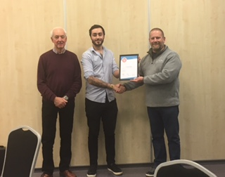

2017 has, so far, brought a mixture of mild and cold winter weather and the IAM is keen for drivers to be aware of the different types of hazards they may face when venturing out in their cars.

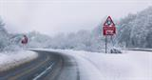
Snowing me, snowing you … there is something we CAN do!
IAM RoadSmart brings you expert advice on driving in snow from its head of driving and riding advice Richard Gladman. Best advice is to avoid travelling in extreme weather. If no one is moving, you just add to the problem - so listen to travel advice.
If you do have to travel in bad weather, plan your journey thoroughly. Think about where you are going and what it will be like all the way along the journey. If you can, avoid travelling on less-used roads or country lanes as these are less likely to be gritted.
Before setting off, clear all your windows and mirrors fully. Clear off snow piled on the roof of your car and the bonnet too, as it can fall and blow on to the windscreen. Don’t leave anything obscured.
Start your car gently from stationary and avoid high revs. If road conditions are extremely icy and you drive a manual car, you should move off in a higher gear rather than first gear. You should stay in a higher gear to avoid wheel spin.
It’s important you get your speed right when travelling in snow. Never drive too fast that you risk losing control, and don’t drive so slowly that you risk losing momentum for getting up a slope.
Increase your following distance from the vehicle in front of you. It may take up to 10 times as long to stop on snow or ice build this into your following distance – this will give you more time to slow down using engine braking which is less likely to induce a skid.
Make sure you slow down sufficiently before reaching a bend so you have enough time to react to any hazards that appear as you go round it – and so you do not skid as well. You should have finished slowing down before you start to turn the steering wheel.
If you break down or have to pull over on a motorway or dual carriageway, you should leave your vehicle and stand to the safe side of it - ideally well over the Armco to the nearside of the road, but not in front of it, when waiting for help.
Richard said: “Many of the problems associated with travel during snow could be avoided if people planned in advance. People routinely travel with only the minimum of safety equipment, without realising their journey could be a lot longer than expected.
“At the very least you should have a shovel, torch, blanket, jump-leads and tow rope. You should ensure your mobile phone is fully charged, and the number of your recovery organisation is saved into it. A bottle of water and a snack may also prove useful and don’t set out without knowing the locations of petrol stations on your way.
“This all might sound obvious, but too many of us forget to do any of this. Don’t be one of the ill-prepared, and listen to the weather forecast for the whole length of a winter journey to help you prepare for it.”

A life for a life?
It’s been a busy festive period for road safety consultations. In the last few weeks major consultations on tougher penalties for the most serious driving offences have arrived alongside one for allowing learners on motorways. Although motorways are our safest roads they do require unique skills which it seems we are all supposed to gain by experience.
Supporting the learners on motorways proposal is something of a no brainer for a road safety charity. The new regulations would only allow tuition with an Approved Driving Instructor (ADI) in a dual controlled car and would be entirely voluntary. No need to travel from Orkney for a motorway test!
Although motorways are our safest roads they do require unique skills which it seems we are all supposed to gain by experience. Given the predominance of tailgating and middle lane hogging at the top of the nation’s driving hate list, it seems not all drivers do! But, don’t forget that anyone can benefit from a motorway refresher or confidence boost tomorrow with an IAM RoadSmart module.
The Justice Department consultation is much more complex and nuanced. On the face of it putting ‘causing death whilst using a motor vehicle’ on the same footing as murder sounds attractive and fair. Ironically this was the case many decades ago when the clamour was to have more specific motoring offences – what goes around comes around!
Victims’ groups do quite rightly feel outrage when Courts only ban or fine those convicted of involvement in a fatal crash. The structure of offences that starts with careless driving and rises to causing death by dangerous driving was meant to offer a proportionate response, but also seems to encourage a ‘plea bargain’ culture where a lower charge is applied to ensure a conviction.
The reality is also that the current maximum sentence of 14 years in prison is seldom applied. Sentences are creeping up but even if life is available it may not be used. Bereaved families are also upset when a guilty plea and good behaviour or time spent behind bars leads to a shorter sentence. These are however fundamental principles of our justice system that go well beyond motoring offences.
At IAM RoadSmart we are listening to our members’ views on the government’s proposals through a web poll. Getting the balance right between punishment and prevention is not going to be easy. There is very little evidence that tough penalties make the worst drivers stop and think before committing deliberate offences.
Human error figures highly in most crashes and we don’t really know if fear of a long prison sentence will solve the problem of momentary lapses or inattention. Thankfully fatal crashes are very rare events but that does mean very few us expect to be involved in one.
At IAM RoadSmart we think that targeted help to change behaviour at the lower end of offending is a more positive approach than ever increasing penalties in an environment when few feel they might get caught. Speed awareness and drink drive rehabilitation courses do appear to reduce reoffending. The evidence for the effect of a prison sentence on motoring offenders is less well known. Given the current bad press for our prison service the thought of spending any time behind bars would worry most law abiding drivers. But will that improve their day to day driving - a good topic for future research I think.
Neil Greig, IAM RoadSmart director of policy and research

What makes you sign on the dotted line?
First car aspirations are always the funniest. If you are like me, you dream without realisation of your bank account and expect the best car out there, something that can reflect who you are or want to be. My dream car is a BMW 1 series; a car of luxury, muscle and ego.
In many cases the first car you purchase is the one that you had your lessons in, due to familiarity and ease but style and brand have become great deciders before purchasing. So by this standard, mine should be a Ford Focus but the car fails to stimulate me. I guess a car to me should be a reflection of personality, as it should speak for you as you drive.
It has been reported from The Society of Motor Manufacturers and Traders (SMMT), that 2.69 million cars were registered last year; 2% higher than in 2015. It said this is due "very strong" consumer confidence, low-interest finance deals and the launch of several new models. The argument is posed: why not have the best if you can afford it, why settle if you can afford to pay bit by bit?
I guess being a Londoner this is flawed as TFL and Uber work out to be much cheaper compared to owning a vehicle and paying congestion charge once you reach the city.
To be fair I think the phrase stands ‘with age comes wisdom’. Studies from Money Adviser show that the youthful attraction of exterior imagery and car branding fall lower down the chain as you age, as the level of demand for family comfortability and safety become greater than style. What was your first car and why? And if you could, would you change it? Samson Ruwangu IAM RoadSmart digital content executive

New fund launched to repair potholes:
Apparently, there will be nearly one million fewer potholes in our roads later in the year following the launch of a £250 million fund to combat the problem. The RAC has welcomed the move but says that prevention is better than cure.
On April 7th last, the Government announced that it will fund local councils a total of £50 million in 2016 and 2017 to repair 943,000 potholes. The Pothole Action Fund will see a similar sum handed out over the next four years after that.

The former Transport Secretary, Patrick McLoughlin, said that the pothole problem was a “blight” and that people will notice improved journeys between now and 2020/21. The RAC reported that pothole-related breakdown call-outs had risen 25% between 2014 and 2015 to 25,487.
Ministers are spending an unprecedented £6.1 billion on maintaining local roads over the five years ahead. The Chief Engineer for the RAC, David Bizley, said: “while any cash to fix potholes is welcome, we will not get on top of the problem until there is a recognition that potholes arise because of a lack of preventative maintenance. Until we start talking about how many potholes we have prevented rather than how many we have filled, we are doomed to a local road network that is the weak link in the transport infrastructure. It’s time for the Government to recognise that local roads are a vital part of the transport infrastructure which should be brought into the scope of the Infrastructure Commission so that they are rightly treated as a long term strategic asset. While the Government’s Road Investment Strategy is ensuring the future ‘fitness-for-purpose’ of the strategic road network in England, there is a very real danger that local roads will suffer ongoing decline through insufficient investment and no long-term strategy to improve them. What use would it be having excellent motorways, major roads, railways, ports and airports if, when getting to or from them, you are faced with pothole-ridden, crumbling local roads where, of course, all journeys start and finish” thanks to Ray Harris-Hawkins

Our next social meeting is on Thursday 2nd February at our new start time of 7.45 p.m. Our speaker will be Mike Webb from Protyre and our venue is, as usual, Kinson Community Centre, Pelhams Park, Millhams Road, Kinson, Bournemouth BH10 7LH. Our speaker for our March meeting will be John Larty from Quick Fit. We look forward to seeing as many of you as possible and please do bring along your family and friends.

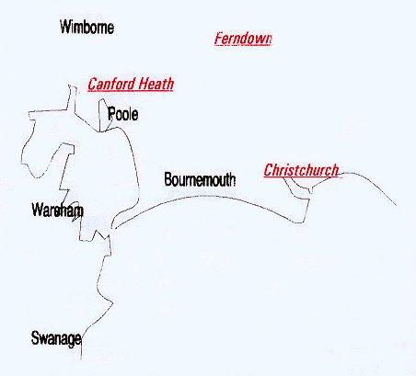

Disclaimer: The views and opinions expressed in News @ 1096 do not necessarily state or reflect the views of the Bournemouth & District Advanced Motorists Group.

