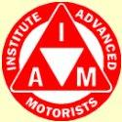
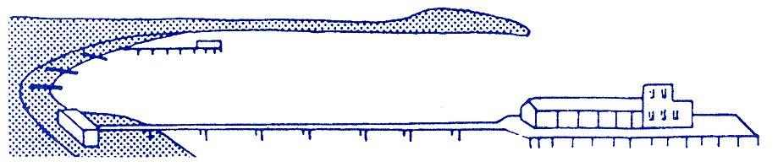
BOURNEMOUTH & DISTRICT GROUP
News @ 1096 April 2016
We enjoyed a most interesting talk by Richard Pearson from Bournemouth Council Road Safety department at our April social meeting. He explained the detail of much data that had been collated over the past few years regarding traffic accidents worldwide and how the UK fared in the ratings table. As far as Bournemouth was concerned in 2014, there were a total of 529 collisions resulting in 1 fatality, 69 serious and 552 slight casualties. The value of prevention of these collisions, according to the report, equates to 33.4 million which demonstrates the massive financial impact that road collisions have on the local economy. The Road Safety team at Bournemouth have collated accident data for different types of roads i.e. built-up, non-built up and motorways and different types of vehicles (including motor cycles), pedal cycles and also pedestrians, happily Bournemouth and Dorset accident rates are average. A lot of time is spent identifying the causes of accidents i.e. cluster spots, roundabouts etc. and much thought is given to designing better options where possible to help traffic flow more freely. If you would like to read more about the Road Safety team’s work, there is a very detailed report on the Borough of Bournemouth’ website at:
http://bournemouth.gov.uk/GettingAbout/TransportDocs/road-safety-report.pdf
Earlier this year, at our February meeting, Brian Chidgey who is now with Dorset County Council Driver Training Unit, talked to us about his career as a Driving Instructor and Clare Heaton a Bournemouth Road Safety Officer contributed to the meeting. Our group photo below shows seated from left David Hodges Associate Co-ordinator, Sue Whitcher Chairman, Alison Shelton BEM & Chief Exec. of Streetwise, Brian Chidgey and Clare Heaton.
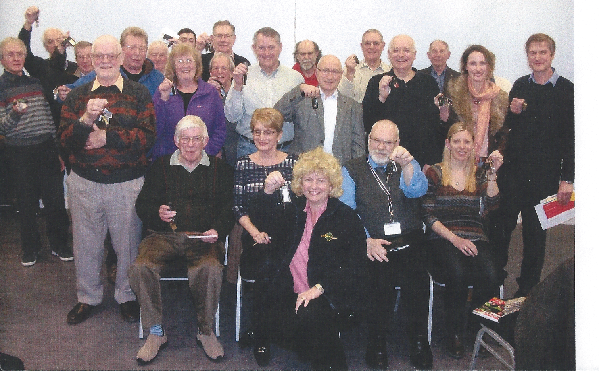
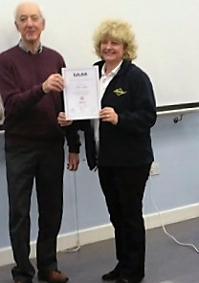

We are delighted to announce that Alison Shelton from Streetwise passed her test in March gaining a F1RST and was presented with her certificate by Richard Jolly.
Alison has now applied to train for her Masters under Richard’s supervision and we wish her the very best for another first class result.
We also wish to congratulate Colin Norton who passed his test in January.

Our new timetable for meetings was well received and the break in the proceedings seemed to be welcomed by quite a few members; the chance to get a cuppa before David and Richard explained that the IAM has decided to re-brand and will very soon be known as IAM RoadSmart. All future advertisement banners and literature will show the IAM as blue rather than the red it has used for the past 60 years; only the car roundel will remain red. There is an introduction and more detail from Sarah Sillars our chief executive officer on page 38 of the spring edition of Advanced Driving.
We recently received a letter from a gentleman called David Cheadle who lives locally and has kindly given his permission for us to reproduce this and his subsequent notes for general interest.

Dear Sir,
I have long admired and respected the cause to which you are committed and to which you give such professional support and encouragement, not least in the high standard of the testing you maintain. Possession of the coveted badge, if justifiably obtained, can only encourage that standard.
My motoring experience spanned some sixty-five years at all hours of the day and night and in all weather conditions, often covering a thousand miles weekly. May I make a few observations on what I see these days as a deplorable lack of both car craft and road craft? The first contributes to the second. That you are making a significant contribution to standards in both fields is highly commendable.
A friend confided that he had had his car six months and did not know how to open the bonnet! Now I am only a passenger, and all too often a reluctant one, thankfully for short journeys only! With very few exceptions I would not consider a journey with most drivers.
The greatly improved performance and facilities provided by the modern car encourages this cavalier attitude and approach to driving at ever increasing speeds with a corresponding lack of a sense of danger. I am concerned, too, how many drivers are able to talk continually whilst driving especially in heavy traffic conditions. The thoughtlessness and ignorance referred to, all too often give also a real lack of passenger comfort. This results from both hard acceleration and braking in short distances, as well as swinging round corners without losing speed. With a badly broken neck this is critical for me!
When wintry conditions persist, it is obvious that motorists generally have no idea how to cope as they sit there, with the driven wheels spinning at speed, but the car stationary!
I feel sure that you would not endorse such practices, but if I am ‘behind the times and out of touch’ then no doubt you will tell me.
Yours faithfully
W D Cheadle

Efficient Driving:
This has a wider brief than, but includes, standards of safety, courtesy and economy. Existing manuals on driving techniques such as ‘Advanced Driving’ are excellent, but there is a further aspect, not easily defined, that goes one stage further. It is a comprehensiveness of approach that starts with the driver’s seating position before even moving off, to journey’s end as the car is garaged.
The main difficulty to be overcome is the widespread assumption that people can either drive or not, and that is the extent of the matter. The result of this thinking is that how the distance covered, be it short or long, is achieved is immaterial. People go by car, whether they drive is a mute point!
A further difficulty is that, in spite of the sustained efforts of your Institute, and there may be other societies with related interests, you are reaching a miniscule percentage of the driving public. That there is no subject to be considered, that people are just not interested in it, is very increasingly obvious.
My remarks are based firmly on my not ever being fully satisfied with my own driving technique, that there is always more to be learned and practised, and to observing the practice of others. Then I must accept that, at the age of 87 and counting, I am long out of date and no longer relevant! I can accept this criticism!
1: Car Choice:
Over many years I had a short list of priorities when choosing my car. This began with the quality of the driver’s seat, as well as the adjustments available. I preferred a more upright stance at the right distance from the steering wheel and the other major controls. Frequently drivers are seen slouching in a semi-recumbent posture and with a line of sight that is limited. The adjustment of the mirrors, both internal and external included being able to use them with little or no head movement. After the seating quality I checked the transmission details, more especially the revolutions at which the engine develops maximum torque. Cruising at maximum torque engine speed produced much better fuel consumption. This I proved over all my motoring life by keeping car log books in which I accurately recorded all fuel purchases and from which I calculated overall consumptions. Forty mpg was my target for local driving and 50mpg for cruising. This applies only if the car boasts a tachometer, of course. Some tyres have a reputation for greater fuel economy, and I favoured the Michelin X tyres. My first set covered 65,000 miles and were still good for another 15,000 miles. Michelin evinced no surprise.
2: Before Leaving the Garage or Parking Space:
Clarity and the degree of vision are paramount. To set off with screen and windows partly obscured with dirt, ice or snow is irresponsible. Are all the lights and direction indicators functioning correctly? Have the levels of oil and fuel been checked. Sealed coolant systems preclude this check. Are the tyre pressures correct?

3: Driver’s Condition:
Are you sufficiently alert, not overtired, alcohol free and fit to be driving?

4: Proceeding:
Firing up the engine and moving off immediately with strong acceleration but without pausing to allow the engine oil to circulate and the computerised systems to operate efficiently, is not advisable. But who cares? An engine should not be allowed to warm up at tickover speeds either.

5: Efficient Driving:
This is a controversial subject and the heart of the matter! It can be defined as proceeding lawfully, (a major feat in itself these days with the plethora of rules and regulations), safely, efficiently and satisfactorily. Most of these objectives have been well covered by those far more capable and erudite than myself, and I do not propose to venture into these areas.

6: Economy Driving:
This aspect, which is the essence of the subject, does not cover advantageous purchasing, insuring and maintaining of a car. It embraces driving in a manner that ensures safety, of course, as a priority, but much more. Attaining journey’s end enjoyably, having used only as much fuel as was necessary, is the target. The widespread view that this means crawling along in the slow lane is as ignorant as it is incorrect. The benefits of economical driving include less weariness for the driver with increased tyre and brake life, and a greater satisfaction. Power steering and automatic gearboxes, whilst being worthwhile improvements, have contributed to the lowering of standards and to driver laziness, in my opinion.

It is evident that driving in the present conditions generally these days means a continuous adjusting of the accelerator and the brakes as traffic ebbs and flows. What is proposed is that the driver’s sight should extend beyond the rear of the car immediately in front. By holding back a little and taking into account the traffic situation ahead, it is possible to proceed without the need for a continuous variation of vehicle speed.

The result of this approach is a smoother, less stressful and more economical drive. With the road congestion that is common, it is helpful as well to take the longer view and choose the better lane for proceeding, provided, of course, that this is not the wrong lane! All too often, drivers deliberately take the wrong lane to jump the queue of traffic. This is neither acceptable practice nor good road manners. But in a culture that encourages everyman to ‘look out for himself’ we should not be surprised.

Motorway driving is a subject in itself, and quite concerning. What always amazed me was the extent to which drivers ignored the weather conditions, the overhead traffic signs, the state of the road surface and the density of the traffic, and then setting their speed accordingly.

If I may intrude a personal experience on the M6 many years ago now? The weather had been dry for weeks and then a light drizzle turned the dust balls on the motorway surface into ball bearings! As soon a traffic conditions called for braking, the vehicles started to slide uncontrollably. Cars, lorries, coaches piled into each other until over 150 vehicles turned into mangled wrecks. This was then replicated on the southbound carriageway.

Snow and ice display a lack of basic knowledge of how to keep going in these conditions as driver’s sit helplessly with fast revving engines and spinning wheels, but without progress! Selecting a higher gear, being moderate with the throttle and avoiding harsh braking means that progress is possible. Many thanks to W.D. Cheadle for this very comprehensive article.

Our next social meeting is on 5th May at our new starting time of 7.30pm at our usual venue: Kinson Community Centre, Pelhams Park, Millhams Road, Kinson when our speaker will be Trevor Clements talking about the Titanic. Please do come along and bring your partners and friends to support your local group.

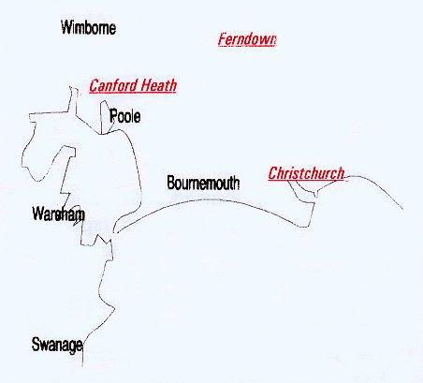

Disclaimer: The views and opinions expressed in News @ 1096 do not necessarily state or reflect the views of the Bournemouth & District Advanced Motorists Group

